CODE OF CONDUCT ON INSIDER TRADING

- Introduction :

Pursuant to Securities and Exchange Board of India (Prohibition of Insider Trading) Regulations, 2015 and SEBI Circular dated:11-05-2015, Infra Industries Limited. (‘the Company’) is required to formulate a Code of Fair Disclosure, Code of Conduct, Code of Internal Procedures for Regulating, Monitoring and Reporting of trading by Insiders for prevention of insider trading by Promoters / Directors / Designated Employees / Connected Person of the Company, in relation to the securities of the company.

Accordingly, the Board of Directors (“the Board”) of the Company has adopted and formulated Codes, in compliance with the applicable regulations of the SEBI and the Listing Agreement and also to upload those codes on Company’s website at www.infra.co.in under the broad heading Investors Centre.

- Definitions :

  - “Compliance Officer” means the Company Secretary of the Company for the purpose of administration of the insider trading policy.

  - “Connected Persons” means:

    - any person who is or has during the six months prior to the concerned act been associated with the Company, directly or indirectly, in any capacity including by reason of frequent communication with its officers or by being in any contractual, fiduciary or employment relationship or by being a Promoter, director, designated officer or an designated employee of the Company or holds any position including a professional or business relationship between himself and the Company whether temporary or permanent, that allows such person, directly or indirectly, access to unpublished price sensitive information or is reasonably expected to allow such access.

    - Without prejudice to the generality of the foregoing, the persons falling within the following categories shall also be deemed to be connected persons unless the contrary is established :

      - an immediate relative and dependent of connected persons specified in clause (i); or

1

    - an intermediary as specified in Section 12 of the SEBI Act (‘the Act) or an employee or director thereof; or

    - an investment Company, trustee company, asset management company or an employee or director thereof; or

    - an official of a stock exchange or of clearing house or corporation; or

    - a member of board of trustees of a mutual fund or a member of the board of directors of the asset management company of a mutual fund or is an employee thereof; or

    - a member of the Board of Directors or an employee, of a public financial institution as defined in section 2 (72) of the Companies Act, 2013; or

    - an official or an employee of a self-regulatory organization recognized or authorized by the Board; or

    - banker of the company; or

    - a concern, firm, trust, Hindu Undivided Family, company or association of persons wherein a Director of the Company or his immediate relative or banker of the Company, has more than ten per cent, of the holding or interest.

  - "Designated Officer/Employees” shall cover the following:

          - General Manager and above or its equivalent in all departments;

          - All employees in Secretarial, Finance and Accounts Department;

          - Such other employees as may be specified and determined from time to time by the Compliance Officer and/or Chief Financial Officer and/or Chairman and Managing Director.

  - “Director” means a member of the Board of Directors of the Company.

  - “Generally Available Information” means information that is accessible to the Public on a non-discriminatory basis.

  - “Immediate Relative” means a spouse of a insider and includes parent, sibling, and child of such insider or of the spouse, any of whom is either dependent financially on such insider, or consults such insider in taking decisions relating to trading in securities

- “Insider" means any person who is:

        - a connected person; or

      - in possession of or having access to unpublished price sensitive information;

- “Key Managerial Personnel” means person as defined in Section 2(51) of the Companies Act, 2013.

2

- “Promoter" shall have the meaning assigned to it under the Securities and Exchange Board of India (Issue of Capital and Disclosure Requirements) Regulations, 2009 or any modification thereof.

- ‘Securities’ shall have the meaning assigned to it under the Securities Contracts (Regulation) Act, 1956 (42 of 1956) or any modification thereof, except units of a mutual fund.

- "Trading" means and includes subscribing, buying, selling, dealing, or agreeing to subscribe, buy, sell, deal in any securities include trading in derivatives of securities, and "trade" shall be construed accordingly;

- "Trading Day" means a day on which the recognized stock exchanges are open for trading.

- “Unpublished Price Sensitive Information (UPSI)" means any information, relating to a Company or its securities, directly or indirectly, that is not generally available which upon becoming generally available, is likely to materially affect the price of the securities and shall, ordinarily including but not restricted to, information relating to the following:

i) | financial results;
ii) | dividends;
iii) | change in capital structure;
iv) | mergers, de-mergers, acquisitions, delisting, disposals and
 | expansion of business and such other transactions;
v) | changes in key managerial personnel; and

  - material events in accordance with the listing agreement.

- Role of Compliance Officer :

The Compliance Officer shall report on insider trading to the Board of Directors of the Company and in particular, shall provide reports to the Chairman of the Audit Committee at such frequency as may be stipulated by the Board of Directors.

The Compliance Officer shall assist all employees in addressing any clarifications regarding the Securities and Exchange Board of India (Prohibition of Insider Trading) Regulations, 2015 and the Company’s aforesaid Codes.

The Compliance Officer shall confidentially maintain a list of such securities as a “restricted list” which shall be used as the basis for approving or rejecting applications for preclearance of trades.

3

- Trading Plan :

An insider, who may be perpetually in possession of UPSI, in order to plan for trades to be executed in future, shall formulate a trading plan for dealing in securities of the Company and present it to the Compliance Officer for approval and public disclosure pursuant to which trades may be carried out on his behalf in accordance with such plan. Trading plan shall :

  - not entail commencement of trading on behalf of the insider earlier than six

months from the public disclosure of the plan;

- not entail trading for the period between the twentieth trading day prior to the last day of any financial period for which quarterly results and annual result are required to be announced by the company and the second trading day after the disclosure of such financial results;

  - Trading plan shall entail trading for a period of not less than twelve months.

- not entail overlap of any period for which another trading plan is already in existence;

v) Trading not entail trading in securities for market abuse.

- The compliance officer shall review the trading plan to assess whether the plan would have any potential for violation of these regulations and shall be entitled to seek such express undertakings as may be necessary to enable such assessment and to approve and monitor the implementation of the plan.

- The trading plan once approved shall be irrevocable and it shall be mandatorily have to be implemented and without being entitled to either deviate from it or to execute any trade in the securities outside the scope of the trading plan.

The Compliance Officer shall consider the Trading Plan made as above and shall approve it forthwith. However, he shall be entitled to take express undertakings as may be necessary to enable such assessment and to approve and monitor the implementation of the plan as per provisions of the Regulations.

However, the implementation of the trading plan shall not be commenced, if at the time of formulation of the plan, the Insider is in possession of any Unpublished Price Sensitive Information (UPSI) and the said information has not become generally available at the time of the commencement of implementation. The commencement of the Plan shall be deferred until such UPSI becomes generally available information. Further, the Insider shall also not be allowed to deal in securities of the Company, if the date of trading in securities of the Company, as per the approved Trading Plan, coincides with the date of closure of Trading Window announced by the Compliance Officer.

Upon approval of the trading plan, the Compliance Officer shall notify the plan to the stock exchanges on which the securities are listed.

4

5. Trading Window :

- The trading period, i.e. the trading period of the stock exchanges, called ‘trading window”, is available for trading in the Company’s securities.

- The trading window shall be, interalia, closed 7 days prior to and during the time the UPSI

- When the trading window is closed, the Specified Persons shall not trade in the Company’s securities in such period

- All Specified Persons shall conduct all their dealings in the securities of the Company only in a valid trading window and shall not deal in any transaction involving the purchase or sale of the Company’s securities during the periods when the trading window is closed, as referred to in Point No. (ii) above or during any other period as may be specified by the Company from time to time.

The Compliance Officer shall intimate the closure of trading window to all the designated employees of the Company when he determines that a designated person or class of designated persons can reasonably be expected to have possession of UPSI. Such closure shall be imposed in relation to such securities to which such UPSI relates.

The Compliance Officer after taking into account various factors including the UPSI in question becoming generally available and being capable of assimilation by the market, shall decide the timing for re-opening of the trading window, however in any event it shall not be earlier than forty-eight hours after the information becomes generally available either through NSE/BSE or newspaper publication whichever is earlier.

The trading window shall also be applicable to any person having contractual or fiduciary relation with the Company, such as auditors, accountancy firms, law firms, analysts, consultants etc., assisting or advising the Company.

  - Pre-clearance of Trading :

- Designated Persons may Trade in the securities of the Company when the trading window is opened and if the value of the proposed trades is above 2,000 shares or up to Rs.10 Lakhs (market value), whichever is less, should pre-clear the transaction, after obtaining approval of the Compliance Officer by submitting an application as per Annexure-1 and an undertaking as per Annexure-2.

- The Compliance Officer shall not approve any proposed Trade by Designated Person if the Compliance Officer determines that such Designated Person is in possession of UPSI even though the trading window is open.

5

  - The Compliance Officer may, after being satisfied that the application and undertaking are true and accurate, approve Trading by a Designated Person, on the condition that the Trade so approved shall be executed within seven trading days following the date of approval.

- The Designated Person shall, within two days of the execution of the Trade, submit the details of such Trade to the Compliance Officer as per Annexure-3. In case the transaction is not undertaken, a report to that effect shall be filed in the said form.

- If the pre-cleared Trade is not executed within seven trading days after the approval is given, the Designated Person must secure pre-clearance of the transaction again.

- A Designated Person who Trades in securities without complying with the pre-clearance procedure as envisaged in these Rules or gives false undertakings and/or makes misrepresentations in the undertakings executed by him/her while complying with the pre-clearance procedure shall be subjected to the penalties as envisaged in these Rules.

- The Compliance Officer may waive off the holding period in case of sale of securities in personal emergency after recording reasons for the same. However, no such sale will be permitted when the Trading window is closed.

- Prohibition of Insider Trading :

An Insider shall not, directly or indirectly :

- Trade in securities that are listed or proposed to be listed when in possession of UPSI

- Trade in securities of the Company except when the Trading Window is open and the Insider is not in possession of UPSI

Provided the restriction in 4(i) above shall not apply to :

  - a transaction that is an off-market inter-se transfer between Promoters who were in possession of the same UPSI without being in breach of these Rules and both parties had made a conscious and informed trade decision; and

ii) Trades pursuant to a Trading Plan set up in accordance with these Rules.

6

8. Preservation of Price Sensitive Information :

- All information shall be handled within the Company on a need-to-know basis and no UPSI shall be communicated to any person except in furtherance of the insider's legitimate purposes, performance of duties or discharge of his legal obligations.

- UPSI may be communicated, provided, allowed access to or procured, in connection with a transaction which entails:

  - an obligation to make an open offer under the takeover regulations where the Board of Directors of the Company is of informed opinion that the proposed transaction is in the best interests of the Company; or

  - not attracting the obligation to make an open offer under the takeover regulations but where the Board of Directors of the Company is of informed opinion that the proposed transaction is in the best interests of the Company and the information that constitute UPSI is disseminated to be made generally available at least two trading days prior to the proposed transaction being effected in such form as the Board of Directors may determine.

However, the Board of Directors shall require the parties to execute agreements to contract confidentiality and non-disclosure obligations on the part of such parties and such parties shall keep information so received confidential, except for the limited purpose and shall not otherwise trade in securities of the Company when in possession of UPSI.

iii) Need to Know:

- “need to know” basis means that UPSI should be disclosed only to those within the Company who need the information to discharge their duty and whose possession of such information will not give rise to a conflict of interest or appearance of misuse of the information.

- All non-public information directly received by any employee should immediately be reported to the head of the department.

- Limited access to confidential information

Files containing confidential information shall be kept secure. Computer files must have adequate security of login and password, etc.

7

9. Other Restrictions :

    - The disclosures to be made by any person under this Code shall include those relating to trading by such person's immediate relatives, and by any other person for whom such person takes trading decisions.

    - The disclosures of trading in securities shall also include trading in derivatives of securities if any and the traded value of the derivatives shall be taken into account for purposes of this Code.

    - The disclosures made under this Code shall be maintained for a period of five year.

- Disclosure Requirements :

  - Initial Disclosure :

Every Promoter, Key Managerial Personnel, director of the Company and each of their Immediate Relatives shall disclose his/her holding of securities of the Company within thirty days of these Rules taking effect as per Form A set out in Annexure-4.

Every person on appointment as a Key Managerial Personnel or a Director of the Company or upon becoming a Promoter shall disclose his / her and immediate Relatives’ holding of securities of the Company as on the date of appointment or becoming a promoter, to the Company within seven days of such appointment or becoming a promoter, as per Form B set out in

Annexure-5.

  - Continual Disclosure :

Every Promoter, employee, Director of the Company and each of their Immediate Relatives shall disclose as per Form C set out in Annexure-6 to the Company the number of such securities acquired or disposed of within two trading days of such transaction if the value of the securities traded, whether in one transaction or a series of transactions over any calendar quarter, aggregates to a traded value in excess of Rs. 10 lakhs.

The disclosure shall be made within two trading days of: a. the receipt of intimation of allotment of shares, or

b. the acquisition or sale of shares or voting rights, as the case may be.

8

- Disclosure to the Stock Exchanges :

The Compliance Officer shall notify the stock exchanges, particulars of the Trades, within two trading days of the receipt of the Continual Disclosure or from becoming aware of such information

- Disclosure by other Connected persons :

The Compliance Officer may, require any other Connected Person to disclose the holdings and trading in securities of the Company as per Form D set out in Annexure-7 at such frequency as he may determine.

11. Penalty for contravention of the code of conduct :

- An Insider who acts in contravention of these Rules shall be liable to have his services or relationship with the Company, as the case may be, terminated.

- Directors, Officers and employees of the Company who violate these rules shall be subject to disciplinary action by the Company, which may include wage freeze, suspension, ineligibility for future participation in the Company’s stock option plans or termination.

- The SEBI or any other appropriate regulatory authority would also be informed of the violation of these Rules so that appropriate action may be taken.

- Code of Fair Disclosure :

A code of practices and procedures for fair disclosure of unpublished price sensitive information for adhering each of the principles is set out below:

  - Prompt public disclosure of unpublished price sensitive information that would impact price discovery no sooner than credible and concrete information comes into being in order to make such information generally available.

  - Uniform and universal dissemination of UPSI to avoid selective disclosure.

  - The Company Secretary shall act as Chief Investor Relations Officer (CIRO) to deal with dissemination of information and disclosure of UPSI.

  - Prompt dissemination of unpublished price sensitive information that gets disclosed selectively, inadvertently or otherwise to make such information generally available.

9

- Appropriate and fair response to queries on news reports and requests for verification of market rumours by regulatory authorities.

- Ensuring that information shared with analysts and research personnel is not UPSI.

- Developing best practices to make transcripts or records of proceedings of meetings with analysts and other investor relations conferences on the official website to ensure official confirmation and documentation of disclosures made.

ix) Handling of all unpublished price sensitive information on a need-to-know basis.

- Other provisions :

  - In case it is observed by the persons required to formulate a code of conduct under sub-regulation (1) and sub-regulation (2) of regulation 9 of the Regulations that there has been a violation of these regulations, they shall inform the Board promptly.

  - In case of any inconsistency of Code with the Regulations and/or for the matters not specified in the Code, the Regulations shall apply accordingly.

Mukesh Ambani
Chairman and Managing Director

10

ANNEXURE-1

SPECIMEN OF APPLICATION FOR PRE-CLEARANCE

Date:

To,

The Compliance Officer,

______________

______________

______________.

Dear Sir/Madam,

Application for Pre-dealing approval in securities of the Company

Pursuant to the SEBI (prohibition of Insider Trading) Regulations, 2015 and the Company’s Code of Conduct for Prevention of Insider Trading, I seek approval to purchase / sale / subscription of _________

equity shares of the Company as per details given below:

- Name of the applicant

- Designation

- Number of securities held as on date

- Folio No. / DP ID / Client ID No.)

- The proposal is for

  - Purchase of securities

  - Subscription to securities

  - Sale of securities

Proposed date of dealing in securities

- Estimated number of securities proposed to be acquired/subscribed/sold

- Price at which the transaction is proposed

- Current market price (as on date of application)

- Whether the proposed transaction will be through stock exchange or off-market deal

- Folio No. / DP ID / Client ID No. where

the securities will be credited / debited

I enclose herewith the form of Undertaking signed by me.

Yours faithfully,

(Signature of Employee)

11

ANNEXURE-2

FORMAT OF UNDERTAKING TO BE ACCOMPANIED WITH THE

APPLICATION FOR PRE-CLEARANCE

UNDERTAKING

To,

The Compliance Officer,

______________

______________

______________.

I, ________________________________, _________________________ of the Company residing at

______________________________________________, am desirous of dealing in ____________shares of the Company as mentioned in my application dated ___________ for pre-clearance of the transaction.

I further declare that I am not in possession of or otherwise privy to any unpublished Price Sensitive Information (as defined in the Company’s Code of Conduct for prevention of Insider Trading (the Code) up to the time of signing this Undertaking.

In the event that I have access to or received any information that could be construed as “Price Sensitive Information” as defined in the Code, after the signing of this undertaking but before executing the transaction for which approval is sought, I shall inform the Compliance Officer of the same and shall completely refrain from dealing in the securities of the Company until such information becomes public.

I declare that I have not contravened the provisions of the Code as notified by the Company from time to time.

I undertake to submit the necessary report within four days of execution of the transaction / a ‘Nil’ report if the transaction is not undertaken.

If approval is granted, I shall execute the deal within 7 days of the receipt of approval failing which I shall seek pre-clearance.

I declare that I have made full and true disclosure in the matter.

Date : Signature : _______________

12

ANNEXURE 3

FORMAT FOR DISCLOSURE OF TRANSACTIONS

(To be submitted within 2 days of transaction / dealing in securities of the Company)

To,

The Compliance Officer,

______________

______________

______________.

I hereby inform that I

- have not bought / sold/ subscribed any securities of the Company

- have bought/sold/subscribed to ________ securities as mentioned below on ____ (date)

Name of holder | No. of securities | Bought/sold/subscr | DP ID/Client ID / | Price (Rs.)
 | dealt with | ibed | Folio No

In connection with the aforesaid transaction(s), I hereby undertake to preserve, for a period of 3 years and produce to the Compliance officer / SEBI any of the following documents:

- Broker’s contract note.

- Proof of payment to/from brokers.

- Extract of bank passbook/statement (to be submitted in case of demat transactions).

- Copy of Delivery instruction slip (applicable in case of sale transaction).

I agree to hold the above securities for a minimum period of six months. In case there is any urgent need to sell these securities within the said period, I shall approach the Compliance Officer for necessary approval. (applicable in case of purchase / subscription).

I declare that the above information is correct and that no provisions of the Company’s Code and/or applicable laws/regulations have been contravened for effecting the above said transactions(s).

Date : ________________________ Signature : _______________

Name :

Designation:

13

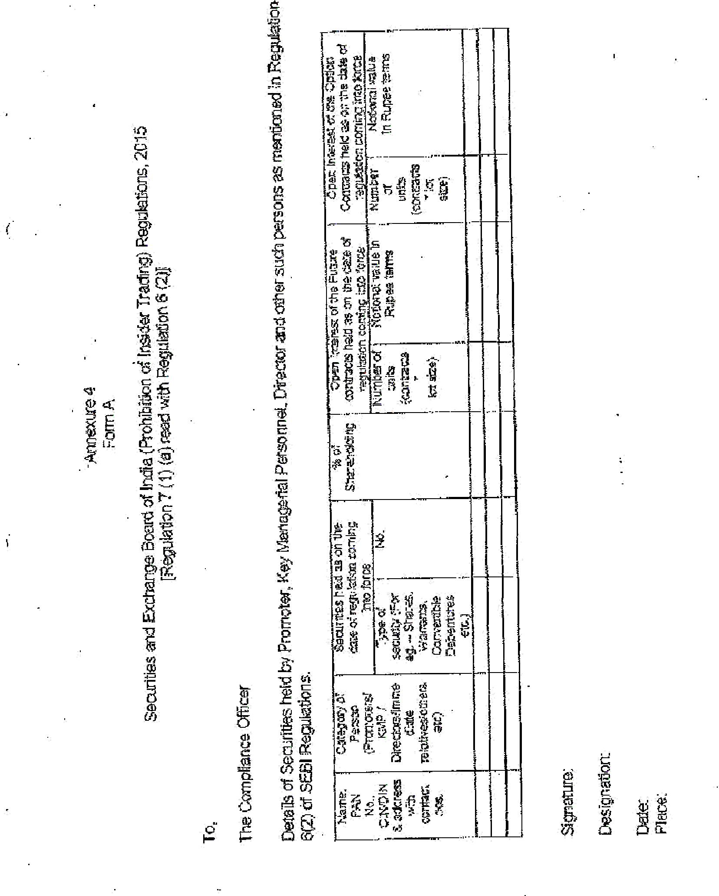

14
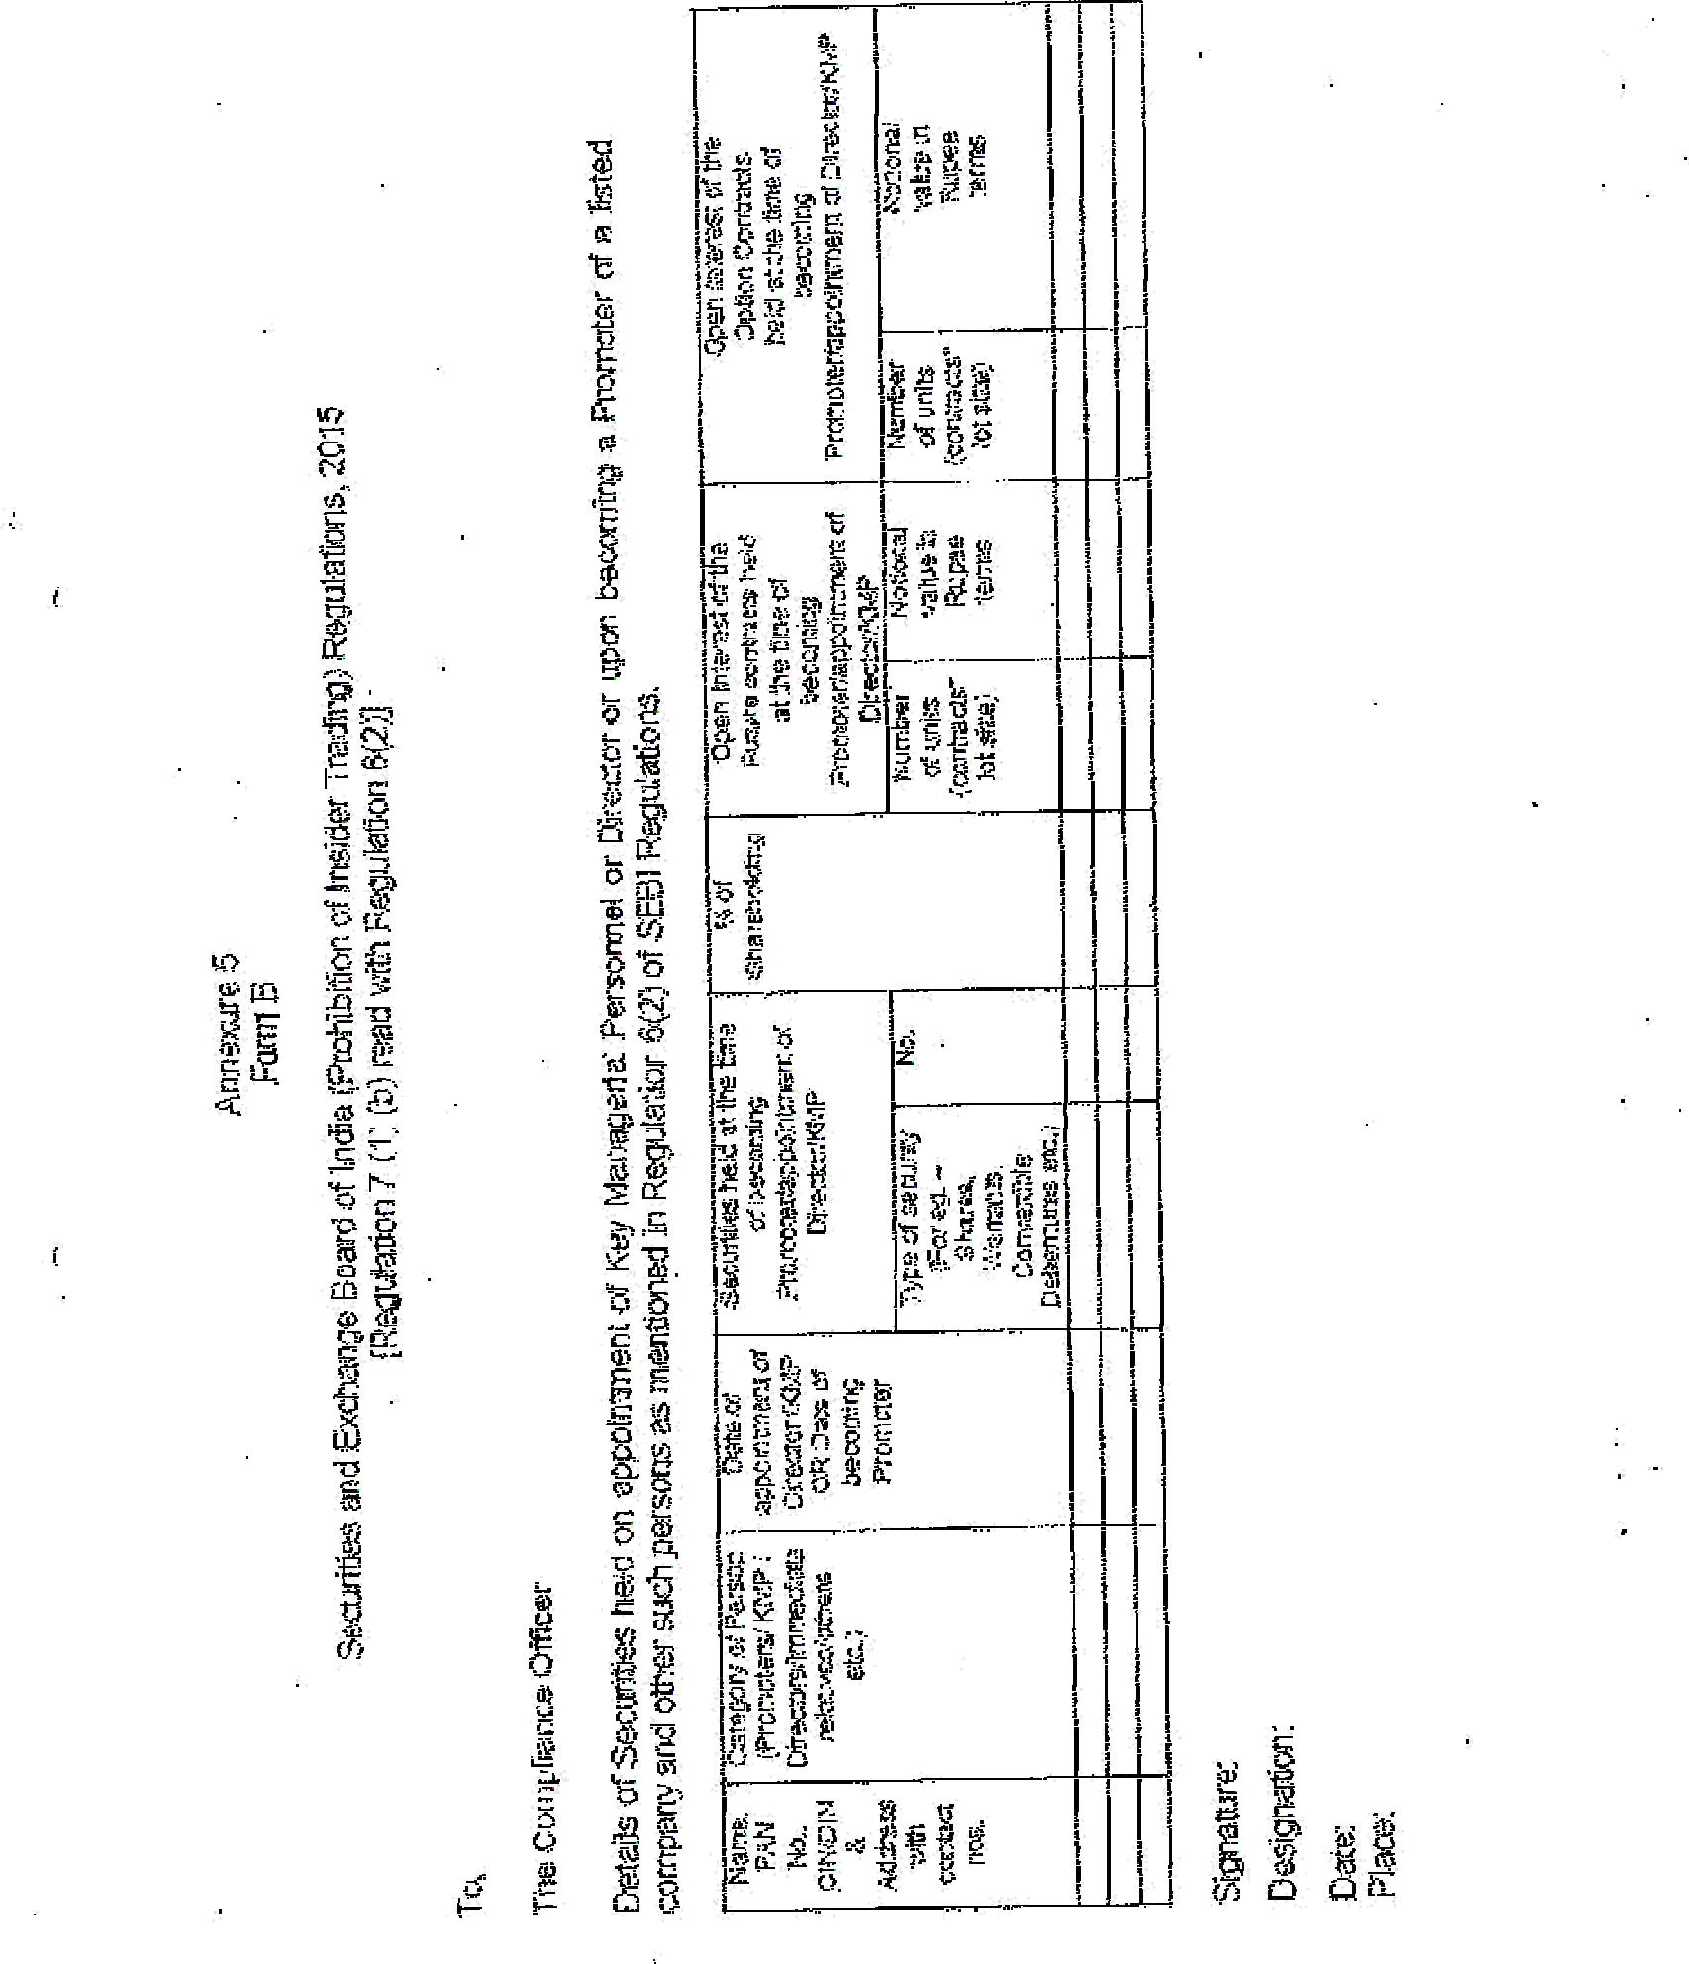

15
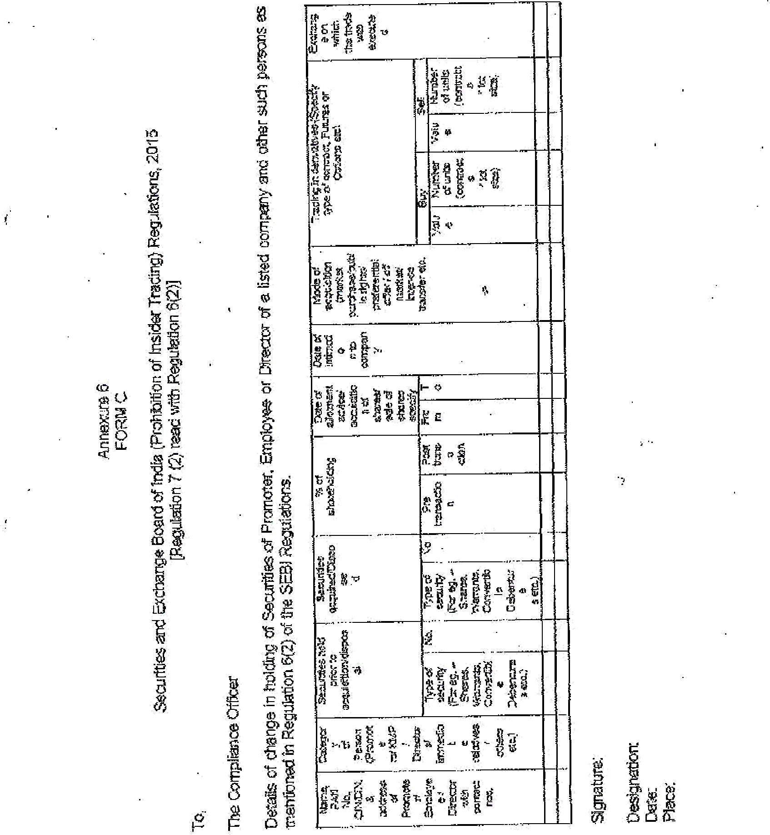

16
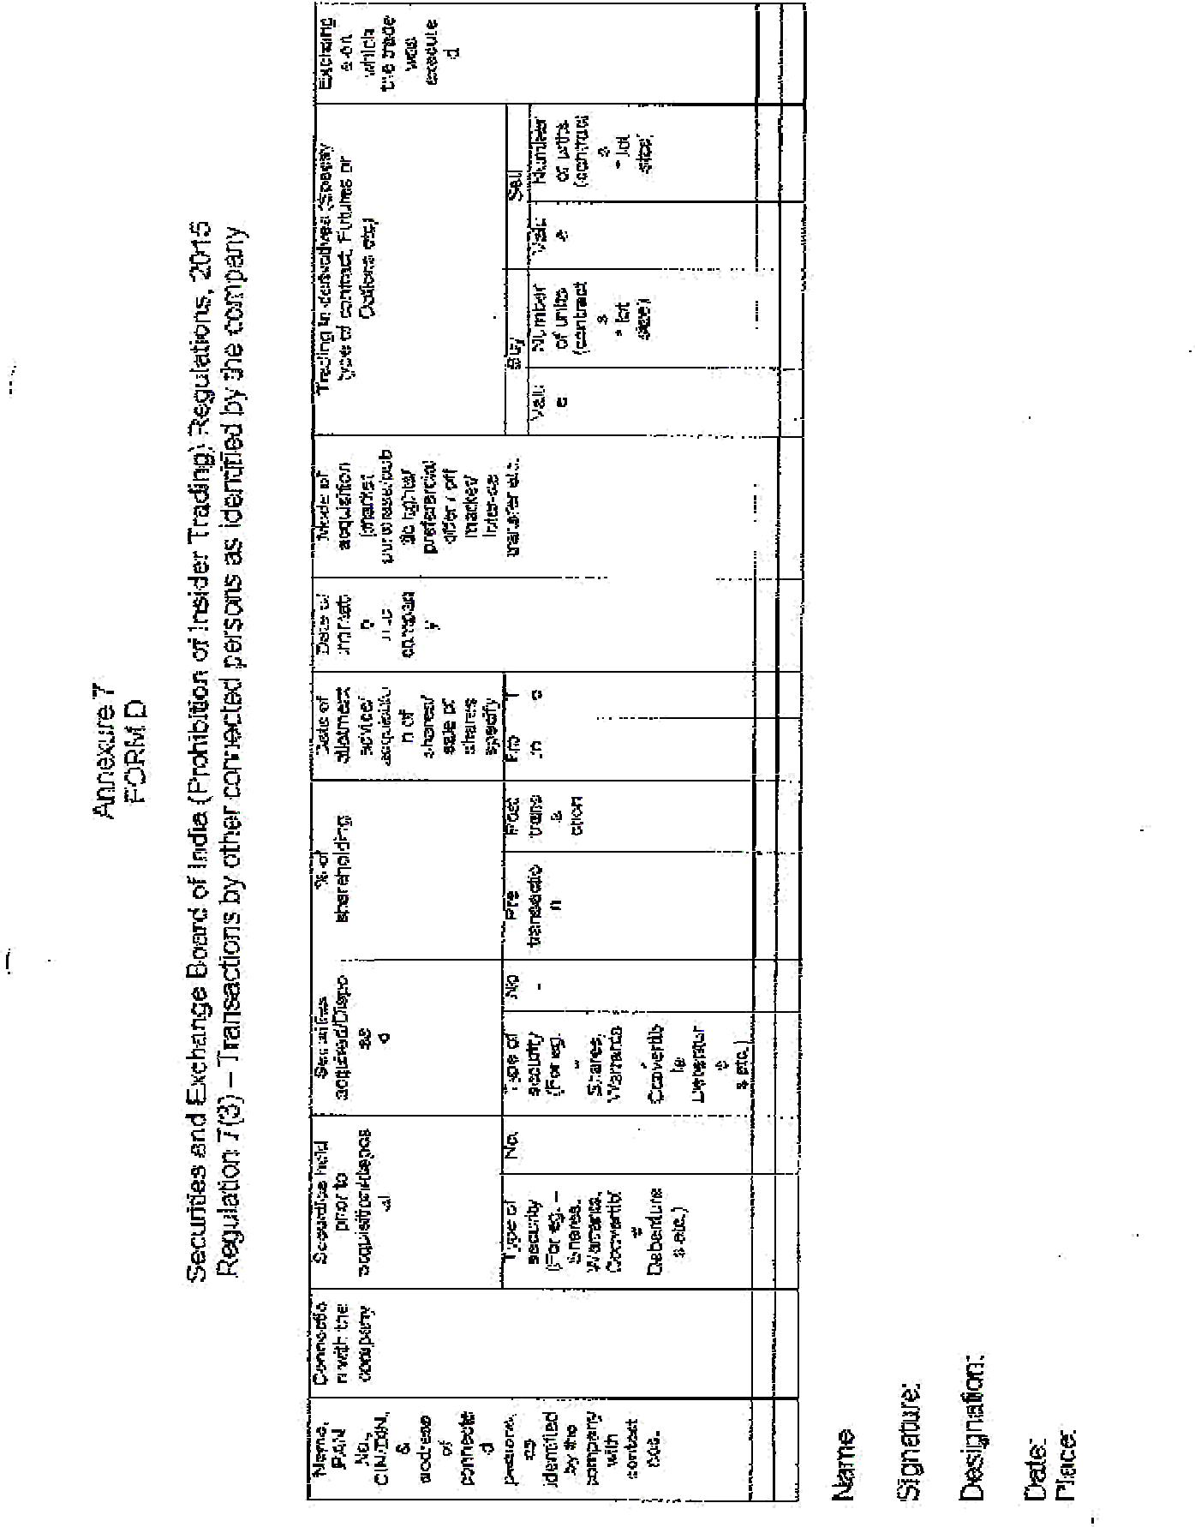

17

